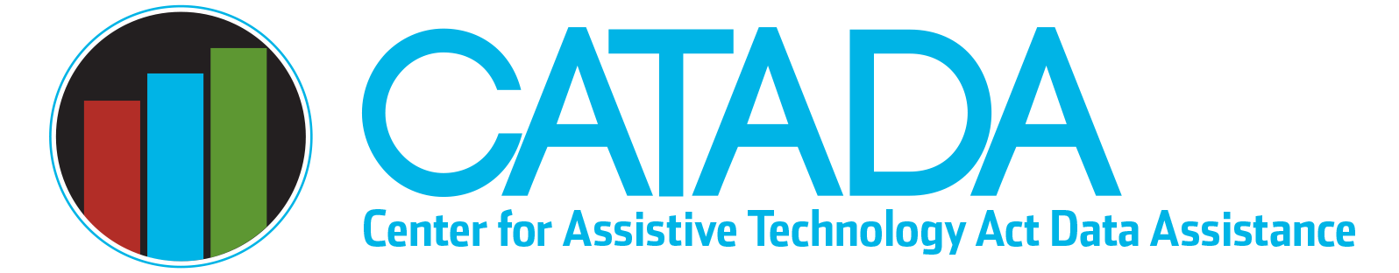

Assistive Technology

“Maker” Activities

With the widespread use of 3D printing, AT fabrication has expanded significantly as a State AT Programs activity. Additionally, a growing number of grantees are including assistive technology (AT) “maker” activities in their state plan for AT and reporting such activities in their annual performance report (APR). AT maker or fabrication activities are typically conducted as an “other state financing activity” that creates savings. This document provides an overview of AT maker and fabrication activities within the context of state-level AT Act activities and data reporting.

AT Maker Activities Defined

State AT Programs are conducted AT Maker activities when a product is made/fabricated and provided to a consumer to meet an AT need. This results in an AT “acquisition.” Making and providing the AT device for no cost or for less than a similar manufactured device would cost (e.g., just charging for materials) is a way for the consumer to acquire the device at a savings.

AT Maker Data Reporting

For maximum consistency, AT maker data should be reported as “Other State Financing activities” that allow consumers to obtain AT for a reduced cost. Grantees who conduct AT maker activities should include them in their state plan by checking “Other state financing that creates AT savings” as an activity conducted in Module D and by completing Module G (checking “AT fabrication program” and then describing the fabrication/maker activities that are conducted).

AT maker/fabrication activities are reported in the state financing module of the APR. In Section C of that module, grantees can “add reduced cost activity,” select “AT fabrication or AT maker program” from the drop-down menu, and then enter recipient, device type, and value data for this activity. An acquisition performance measure and satisfaction data must also be collected/reported for each recipient (same as is done for all other state financing and reuse recipients).

Last updated January 2023

