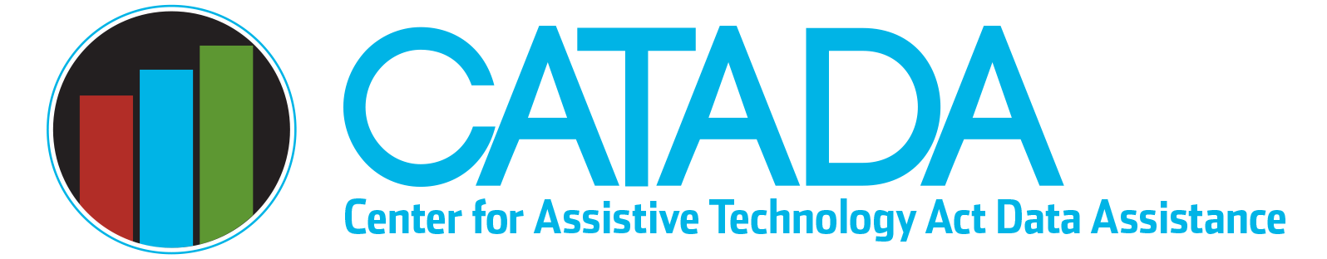

Annual Performance Report Data Structure

Financial Loan — acquisition event core record
- Multiple data elements for each loan made
- One or more AT devices for each loan made
- One acquisition performance measure and one satisfaction rating for each loan made

Other State Financing (direct provision or savings) — acquisition event core record
- One recipient for each other state financing event reported (must be unduplicated for the same event within a reporting period, but can be duplicated if a second event occurs much later within the same reporting period)
- One or more AT devices in one or more AT type categories for each other state financing event reported
- One acquisition performance measure and one satisfaction rating for each other state financing event reported

Reuse — acquisition event core record
- One recipient for each reuse event reported. Recipients must be unduplicated for same event within a reporting period. Recipients can be duplicated if a second event occurs much later within the same reporting period (e.g., a person acquires reused devices and returns six months later to obtain additional devices is typically reported as two reuse events).
- One or more AT devices in one or more AT type categories for each other reuse event reported.
- One acquisition performance measure and one satisfaction rating for each reuse event reported.

Device Loan — acquisition or decision-making event core record
- One borrower type for each device loan event reported
- One or more AT devices (usually in one AT type) for each loan event reported
- One performance measure (access or acquisition) and one satisfaction rating for each loan event reported.

Demonstration — decision-making event core record
- One AT type (regardless of number of devices demonstrated) for each device demonstration event reported
- One or more participants with one decision-maker identified and all other participants reported for each demo event
- One access performance measure for each demo event reported
- Multiple satisfaction ratings, one from each participant reported for demo event

Training — training event core record
- Number of participants in event reported by participant type categories
- Number of participants in event reported by geographic distribution categories
- Number of participants in event reported by topic categories
- One ICT accessibility training performance measure for each participant reported in ICT accessibility topic category

Acquisition Events (Financial Loan, Other State Financing, Reuse, Device Loan)
- Data system must support one recipient/borrower with multiple associated devices acquired within AT type or across AT types reported as one acquisition event
- Data system must support only one performance measure per acquisition event and must ensure all non-respondents are counted

Access Events (Device Loan and Device Demonstration)
- Data system must support one borrower with multiple associated devices borrowed-returned (usually within one AT type) reported as one device loan access event
- Data system must support one AT type with one decision-maker and optional additional associated participants reported as one device demonstration access event
- Data system support only one decision-making performance measure per access event and must ensure all non-respondents are counted

Last updated January 2023

