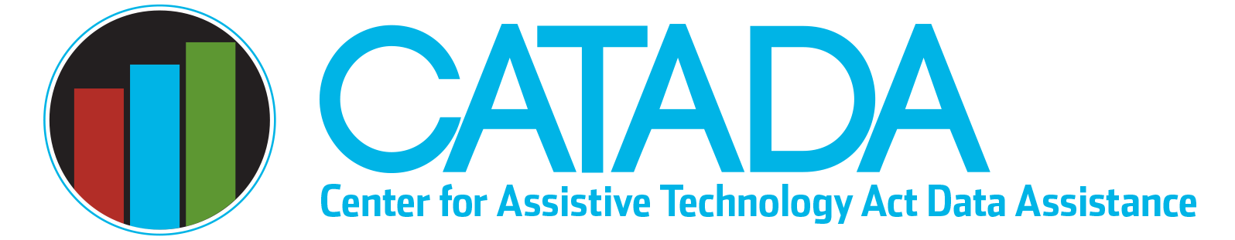

Flexibility and Comparability —
Data Reporting

In general, State AT Programs are expected to conduct all four of the state-level activities along with all of the state leadership activities authorized in Section 4 of the AT Act. However, the law provides for two exceptions to conducting all four of the state-level activities, flexibility and comparability.

Flexibility
Section 4(e)(5) provides that “a state may use funds that the state receives under a grant awarded under this section to carry out any 2 or more of the activities described in paragraph (2),” which are the four state level activities. That section goes on to provide a special rule that requires states who use flexibility “shall use not more than 30 percent of the funds made available through the grant to carry out such activities,” meaning state leadership activities. This means a grantee can choose not to conduct up to two state level activities. Grantees who claim flexibility in a given fiscal year DO NOT report data for that activity during that fiscal year. A maximum of 30% of total expenditure is allowed for state leadership activities, with the remainder of 70% or more allocated to the other two or three state-level activities the state will conduct.

Comparability
Section 4(e)(1)(B) of the AT Act provides that “a state shall not be required to use a portion of the funds made available through the grant to carry out the category of activities described in subparagraph (A), (B), (C), or (D) of paragraph (2) if, in that state — (i) financial support is provided from State or other non-federal resources or entities for that category of activities; and (ii) the amount of the financial support is comparable to, or greater than, the amount of the portion of the funds made available through the grant that the state would have expended for that category of activities, in the absence of this subparagraph.” To simplify, this means that a grantee can choose to not conduct a state-level activity if that activity is supported comparably with nonfederal funds so long as the amount of financial support provided from nonfederal resources is comparable or greater than the amount that the grantee would have allocated for the activity.

The AT Act as reauthorized in 2022 now requires grantees who claim comparability for a state level activity to report data for that activity in their Annual Progress Report (APR). Section 4(f)(2)(A) reads as follows: “Each state shall prepare and submit to the secretary an APR on the activities carried out by the state in accordance with subsection (e) including activities funded by state or other non-federal sources under subsection(e)(1)(B).”

When a grantee claims comparability in their State Plan, they must also provide a description of the comparable activity and comparable financial support. This includes describing the comparable activity, who conducts and supports the activity, and what makes it comparable both in terms of resources supporting the activity and how the activity is related to the purposes of the AT Act. Unlike claiming flexibility, the required state-level and state leadership expenditure percentages are not changed by claiming comparability.

Performance Measures
Before claiming flexibility or comparability, grantees should make sure they have sufficient data for both Annual Progress Report (APR) performance measures — acquisition (state financing, reuse activities, and non-decision-making device loan) and access (decision-making device loan and demonstration activities). The elimination of one activity in either area (acquisition or access) will reduce the scope of services producing data for that measure, and it is important to make sure the remaining services are robust enough to provide stable acquisition and/or access performance measure data.

Last updated January 2023

