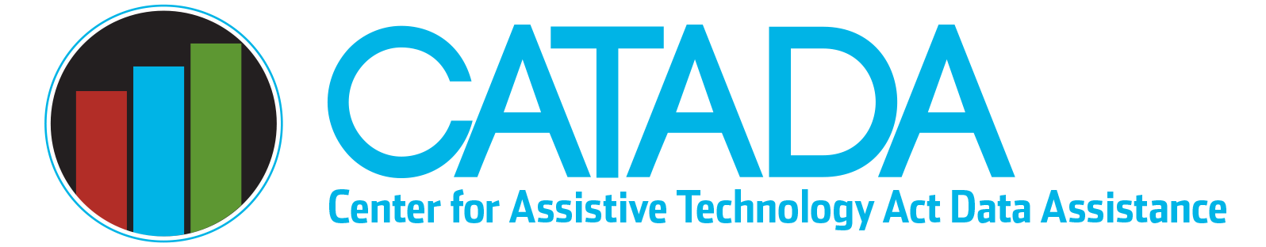

Annual AT Data & Fiscal Calendar

October
- Day 1. Start of new federal fiscal year (FFY), Oct 1 through Sept 30. FFY is named by the second half of the year (the longer nine-month portion, e.g., FFY2020 is 10/1/19–9/30/20).
- Before end of month. Review prior-year APR cumulative data to ensure accuracy and validity. Only data still unavailable might be performance measures, especially for device loans just “closed.”

November
- Before end of month. Review current-year APR data to ensure consistency, accuracy, and currency of data collected and reported internally and by subcontractors.
- Day 30. Target date for APR data entered into NATADS, validated, and ready to submit. Request CATADA staff review of data before final submission.

December
- First week of month. Target this week to address any issues identified by CATADA, review and secure final approval from authorized representative.
- Mid-month. Mark APR data complete and submit in NATADS.
- Day 31. APR data reporting deadline for previous fiscal year data. All carryover FY award funds MUST be liquidated! Verify full liquidation with PMS print out.

January
- Variable Date. Review PMS first quarter report for all open FFY awards by asking fiscal office for print copy. Verify obligation and liquidation status of previous FFY award(s) — should be fully obligated and targeted to liquidate by April 1. Review first quarter of current FFY APR data to ensure fidelity of data collected internally and by contractors.

March–June
- Variable Date. State plan (three-year or annual update) typically due not later than end of June. Most recent previous advisory council meeting should address planned content and/or updates for state plan.

April
- Day 1. Target for all carryover FFY award funds to be obligated and liquidated. Any carryover funds not liquidated must be reviewed to ensure liquidation will occur as soon as possible. De-obligate/re-obligate funds to ensure all funding is obligated and can be liquidated on time.
- Day 30. Review PMS second quarter report for both FFY awards and second quarter of current APR data.

July
- Day 31. Review PMS third quarter report for both FFY awards and third quarter of current APR data. Take immediate action to rectify any fiscal or data problems before September 30!

September
- Day 1. Review and verify liquidations for carryover fiscal year(s). Immediately take action to ensure obligation and liquidation.
- Day 30. All carryover FFY funds MUST be obligated!

Last updated January 2023

