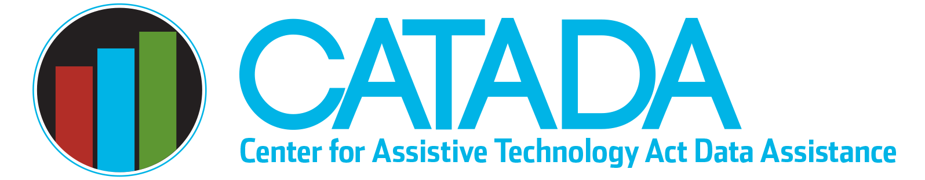

Assistive Technology

Advisory Council

Section 4(c)(2)(A) of the Assistive Technology (AT) Act requires all grantees have an advisory council. The role of the advisory council is to “provide consumer-responsive, consumer-driven advice to the state for planning, implementation, and evaluation of the activities carried out and through the grant.” While the law only requires the council to advise the State AT Program, each grantee can determine the level of authority the council will have, which can include more decision-making authority. In addition, Section 4(c)(2)(D) stipulates that no changes are required to governing bodies of incorporated agencies that carry out the State AT Program.

Required Membership
Membership of the council is prescribed in Section 4(c)(2)(B) of the AT Act. The council must have individuals with disabilities who use assistive technology or the family members/guardians of such individuals (generally called consumers) as members. Consumers must be the majority, defined as at least 51% consumer members, and agency members (described below) cannot count as consumers even if they have a disability.

Required agency representatives include the following with two new required agency representatives added in the 2022 AT Act reauthorization:
- A representative of the state vocational rehabilitation (VR) agency and a representative of the blind VR agency, if such agency is separate from general VR
- A representative of the state education agency
- A representative of the state workforce development board
- A representative of a center for independent living in the state
- A representative of the alternative financing program, if there is such program, it is separate from the State AT Program, and it is operated by a non-profit entity
- One required agency representative picked from following options:
- Medicaid state agency
- State agency administering Developmental Disabilities Act
- State agency administering or organizations funded under Older Americans Act
- Organization representing veterans
- University Center for Excellence in Developmental Disabilities (UCEDD)
- State Protection and Advocacy System
- State Council on Developmental Disabilities

State AT Programs can also have additional council members as appropriate to meet the unique needs of their state/territory. Examples of other representatives frequently reported as members of the advisory council include:
- Early intervention/child services state agency
- State deaf/hard of hearing commission/office
- State insurance agency
- State library/secretary of state/talking books agency
- State ADA office/disability commission/advocacy office
- State legislators
- State parent training information center (IDEA funded)

For each agency member added as an official member, a consumer (as defined previously) must also be added to maintain the required consumer majority. As a result, adding a significant number of optional agency members can result in a council that is quite large.

Last updated January 2023

