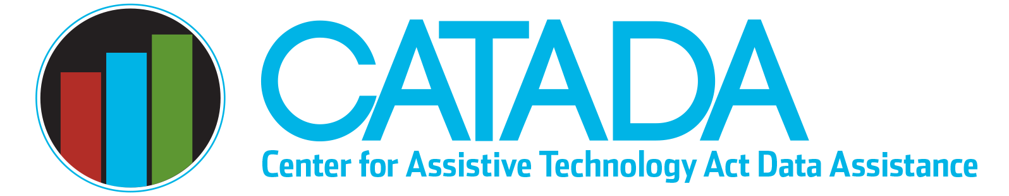

When is “demonstrating devices” a device demonstration?

It can be easy to assume that “demonstrating AT devices” means you are doing a device demonstration for purposes of AT Annual Progress Reporting. However, it is just as likely that you are doing a training or public awareness activity that includes showing AT device features. Just because you “demonstrate a device” or show AT features does NOT mean you conducted a device demonstration as reported in the Annual Progress Report (APR). This data brief provides a discussion of differentiating between device demonstration, training, and public awareness activities for AT APR reporting purposes.

Demonstration
Device demonstrations compare the features and benefits of particular AT devices or a category of devices for an individual or small group of individuals. The purpose of a device demonstration is to enable an individual to make an informed choice. Whenever possible, the participant should be shown a variety of devices to compare features to support informed decision-making.
In a device demonstration, individual, guided exploration of device(s) is provided to the decision-maker by someone who has technical expertise related to the device(s). This expert may be in the same location as the participant or may assist the participant through the internet or a distance-learning mechanism that provides real-time, effective communication to deliver the necessary device exploration. A demonstration is characterized by its interactive nature whereby the participant can interact with an expert to increase their knowledge and understanding about the details and functions of a device; the participant drives the demonstration and has the ability to interact and have their individual questions about the device addressed. If the demonstration is conducted via the internet or distance-learning mechanism, it must be a real-time, interactive demonstration that provides one-on-one assistance to the participant. A web-based demonstration that is archived or is a static presentation without interaction is considered an awareness activity, not a demonstration.
If a demonstration is to be conducted without the participant having direct (hands-on) access to the device(s) to be demonstrated, the interaction must be structured to ensure the device can be adequately explored to enable decision-making. Types of AT devices will vary in their ability to be adequately explored in a demonstration without the device being in the hands of the participant. For example, a demonstration of a daily living aid like a “pill minder” might be done with the participant asking the demonstrator to fill, set, and use the device while they watched on interactive video that might provide adequate information for decision-making. However, having a demonstrator “show” a Braille note-taker to an individual with a vision disability via interactive video would not be adequate.
One participant in each demonstration must be identified as the decision-maker who completes the performance measure. This is typically an individual with a disability or a parent/guardian when one of those participant types is part of the demonstration, and they are making a decision for themselves or on behalf of their child/family member. The identified decision-maker participant will choose one of the following responses to the access performance measure question, “What decision were you able to make after the demonstration?”
- Decided that AT will meet my needs or the needs of someone I represent
- Decided that AT will not meet my needs or the needs of someone I represent
- Have not made a decision

While a service provider (i.e., teacher, OT, PT, SLP) can be the decision-maker participant in a demonstration who completes the performance measure, those demonstration events require a bit more oversight to ensure fidelity of data. A service provider must clearly be making a decision on behalf of a specific known individual with a disability they are representing, not just responding generically with reference to their clients/students. For example, a teacher would need to be making a decision on behalf of one specific known student’s needs, not based on general needs of multiple students in their classroom.

Training
Training activities are instructional events, usually planned in advance for a specific purpose or audience, which are designed to increase participants’ knowledge, skills, and competencies regarding AT. Such events can be delivered to large or small groups in person, via telecommunications, or using other distance education mechanisms. In general, participants in a training can be individually identified and could complete an evaluation of the training. Examples of training include classes, workshops, and presentations that have a goal of increasing skills, knowledge, and competency, as opposed to training intended only to increase general awareness of AT. A good way to identify training is to ask if learner objectives include increasing skills/competency. Training, even if it includes showing devices, is fundamentally different from device demonstrations as the outcome result for a demonstration is informed decision-making rather than increased knowledge, skills, and competencies.

Public Awareness Activities
Training activities have more depth and breadth than public awareness activities, which are not focused on skill building and competency development. If the purpose of a training session is to create awareness, the training session should be classified as a public awareness activity. In general, participants in training can be individually identified, while in awareness activities, it may not be possible to identify each individually.
Public awareness, especially expo-type events, frequently include showing devices (demonstrating devices). These are NOT device demonstrations unless there is a dedicated guided exploration of devices with an identified individual decision-maker participant from whom a valid performance measure decision is collected. Doing general show-and-tell as individuals come by an expo both is not doing device demonstrations. The key difference is an informed decision-making goal for device demonstrations rather than sharing general device information about a variety of AT with a goal of raising awareness for public awareness activities.

Last updated January 2023

