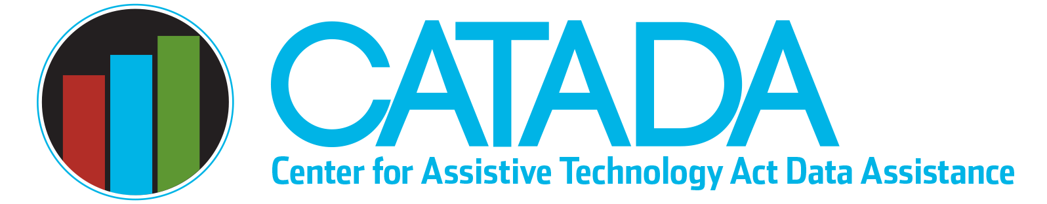

Lead Agency & Implementing Entity

Section 4(c)(1) of the Assistive Technology (AT) Act requires the governor to designate a public lead agency to submit the application for (i.e., state plan for AT) and receive the Section 4 formula grant award, administer those funds, and submit required data (Annual Progress Report). This section also permits the governor to designate a non-public or public “implementing entity” to carry out all the Section 4 state-level and leadership activities. The lead agency must establish a contract or other administrative agreement with the governor-designated implementing entity. This provision provides the governor with the authority to identify the entity best equipped to be the “State AT Program” and provide all the required Section 4 activities even if it is not a public entity and thus cannot be designated as the lead agency. Once a lead agency and/or implementing entity is designated, the governor can only re-designate for “good cause” as to why the agency previously designated should not serve, see Section 4(c)(1)(C).
The State Plan for AT is used to officially change a lead agency or implementing entity. Each State AT Program verifies their lead agency and implementing entity (if one is designated) annually in the State Plan for AT through assurance #3, which reads as follows: “The Lead Agency submitting this plan is the State agency that is eligible to submit the plan, and if an Implementing Entity is identified, it is designated to implement the required AT Act activities.” If a change in lead agency or implementing entity is requested, the State Plan must “provide a written description of the rationale for the requested change” (see Section 4(d)(2)(B)). This request is then considered for approval by the Administration for Community Living.
According to 2021–23 State Plan data, 15 states have governor-designated implementing entities. Most (13) are private non-profits who are not eligible to be the lead agency. The remaining 41 grantees have only a governor-designated lead agency, with 21 of those as state agencies and the other 20 higher education. More detailed data is available on the CATADA data portal. Many lead agencies contract out for implementation of some or all activities. Such contracts are solely at the discretion of the lead agency and can be one large contract or multiple contracts.
Governor designation of an implementing entity:
- Allows the governor to ensure a non-public agency that is the best entity to be the State AT Program can serve in that role even though they cannot be the lead agency
- Provides an assurance of stability for these non-profit organizations (many of which were created solely to be the State AT Program) and creates continuity of service for statewide AT Act activities
- Provides lead agencies with the legal basis to contract outside the bidding process as a sole source vendor (e.g., the designated implementing entity is the only one eligible to provide the required Section 4 activities as they are legally designated to do so)
Last updated January 2023

